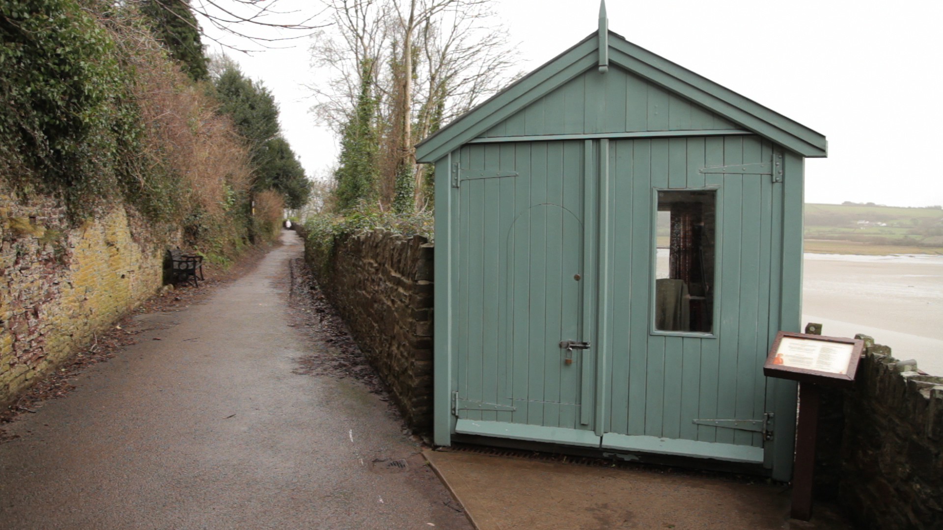
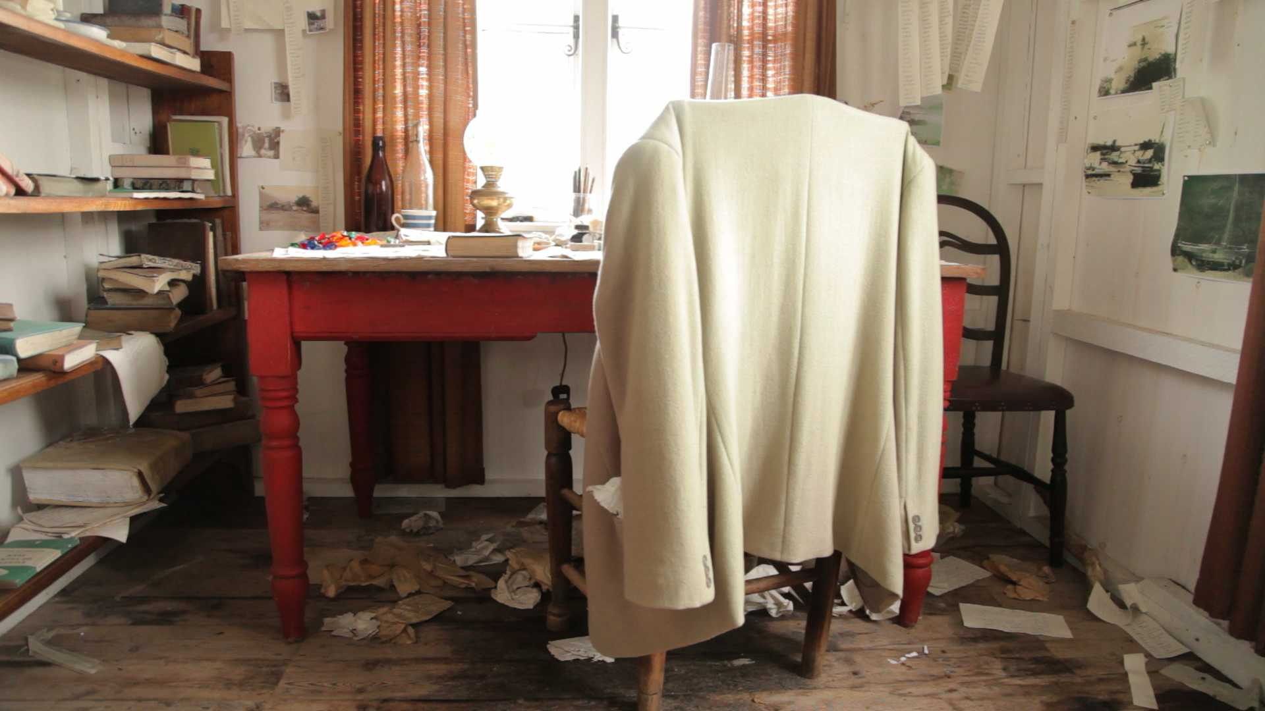
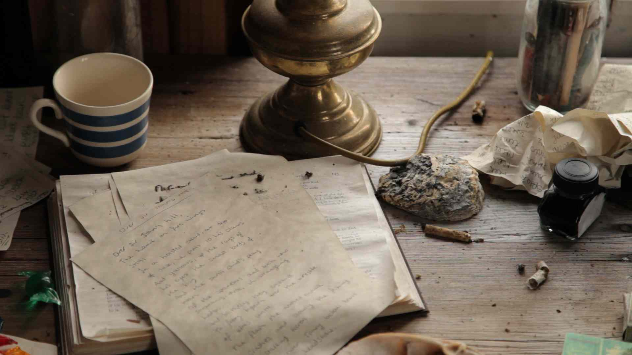
The Writing Shed

Dylan Thomas would go to write in The Writing Shed, an old bicycle shed above his house, The Boathouse, in Laugharne.

Poems written here include ‘Do Not Go Gentle’ and ‘Over Sir John's Hill’ as well as his most famous play for voices, Under Milk Wood.

Copies of his books and his notes show how he used to play a lot with words and make lists of words, until he found exactly the right ones to use.

A replica of the Writing Shed was made in 2014. It tours Wales so that people can see the room where Dylan wrote many of his most famous works.

Although the shed wasn’t very luxurious and probably wasn’t often very tidy, the peace and quiet and the view of the sea would inspire him to write.

